|  |  |  |  |
| --- | --- | --- | --- |
| **PAPER CODE** | **EXAMINER** | **DEPARTMENT** | **TEL** |
| **MAN471** | **Roland Berberich** | **IBSS** | **4985** |

**2nd SEMESTER 2017/2018**

**Assessed Coursework**

**Fundamentals of Project Management**

**SUBMISSION DEADLINE: Thursday 31st May 2018**

**INSTRUCTIONS TO CANDIDATES**

1. The assignment comprises **35%** weight of the final module mark.
2. This assignment consists of three (3) parts: A, B and C. You must complete **all** questions in part A and B and select **one** (1) questions in part C.
3. All answers must be in English only and compromise of full sentences, bullet points are not acceptable.
4. The electronic copy (in MS Word, **not** PDF) of the report must be submitted via ICE before the deadline. **All essays will be processed through Turnitin for a plagiarism and originality check. Please refer to the corresponding policies! Paper copies are not required.**
5. Where indicated MS Project Files or ProjectLibre files must be produced and submitted via ICE.
6. University policy on late submission will be followed.
7. Ensure that you comply with file naming conventions; a cover sheet is not required.
8. The feedback and general marking criteria are following on the next 2 pages.
9. Good luck.

**This page intentionally blank for feedback!**

**General marking criteria:**

All questions have their respective marks attached in brackets, e.g. (10).

Do not copy and paste the book or other student’s answers. All answers must be coming from yourself, citing appropriate references where applicable.

Basic answers will account for 50-60% of the marks for the answer, more elaborate answers will connect the topic with other areas of Project Management, linking theory to practice (examples) and explain the connections in detail. For full marks appropriate references must be chosen and cited using APA or Harvard style referencing.

Marks will be deducted for improper formatting (see handbook)!

## **Section A Short Questions (10 marks)**

As a starter please find below ten (10) short answer/true-false questions. They can be answered in one or two sentences. Each of them is awarded one (1) marks.

1. Question: The only considerations in Project Management are “time, cost, quality”

A: False, because for the modern project management. Time, cost and quality no longer good enough.

1. Question: What are the four stages during the Project lifecycle?

A: Defining, Planning, Execution and Closure.

1. Question: Projects that are over budget are not successful!

A: False, because the triple constraint was once the standard by which project performance was routinely assessed. If the project can be accepted by the customer and create value that is a success project.

1. Question: The Project Manager is the only authority in the Project.

A: False, in a partnership, each member of project team is responsible for the project’s outcomes and current situation, whether it is positive or shows evidence of problems.

1. Question: Projects are independent from the underlying organization.

A: False, there are three different management structures can be used by manager, which include functional organization, dedicated project teams and matrix structure. In dedicated project teams and matrix structure, project is not independent from the underlying organization.

1. Question: Slack is a good time to rest.

A: False, Slack tells us how long an activity can be postponed until it affects Project Duration. Slack allows some flexibility in scheduling and resource management, thus can affect the budget.

1. Question: Leadership skills are irrelevant for a Project Manager, they simply give orders.

A: False, leadership is distinguishable from other management roles in a number of ways. A manager is an individual who has received a title within the organization that permits her to plan, organize, direct, and control the behavior of others within her department or area of oversight.

1. Question: Outsourcing is never a good idea.

A: False, the motivation of outsourcing is faster, cheaper, expertise and resource shortage. Although there are many disadvantages of outsourcing such as security and cost. However fair contracts, long term relationships and other effective method can solve this problem

1. Question: Risk Management can be done very quickly and easy. There is no need to waste your time.

A: False, risk management consists of anticipating, at the beginning of the project, unexpected situations that may arise that are beyond the project manager’s control. These situations have the capacity to severely undermine the success of a project.

1. Question: After more than 50 years of experience Project Failure is a problem of the past.

A: False, sometimes the best plan and action on the most careful selected Project still lead to failure.

## **Section B Project Management Exercises (65 marks)**

Section B and C consists of Project Management exercises and may require you to produce appropriate charts, figures and PM software output. Each question has detailed instructions for you and you must answer all questions.

**1 Project Selection at First International (15 marks)**

Phyllis Henry, vice president of new product development, sat at her desk, trying to make sense of the latest new project proposals she had just received from her staff. First International, Inc., a large developer of business software and application programs, had been experiencing a downturn in operating revenues over the past three quarters. The senior management team was feeling pressure from the board of directors to take steps to correct this downward drift in revenues and profitability. The consensus opinion was that they needed some new product ideas, and fast.

The report Phyllis was reading contained the results of a project screening conducted by two independent groups within the new product development department. After several weeks of analysis, it appeared that two top contenders had emerged as the optimal new project opportunities. One project, codenamed Janus, was championed by the head of software development. The other project idea, Gemini, had the support of the business applications organization. Phyllis’s original charge to her staff was to prepare an evaluation of both projects in order to decide which one should receive support. Because of budget restrictions, there was no way that both projects could be funded.

The first evaluation team used a scoring model, based on the key strategic categories at First International, to evaluate the two projects. The categories they employed were: (1) strategic fit, (2) probability of technical success, (3) financial risk, (4) potential profit, and (5) strategic leverage (ability of the project to employ and enhance company resources and technical capabilities). Using these categories, the team evaluated the two projects as shown here. Scores were based on: 1 = low, 2 = medium, and 3 = high.

|  |  |  |  |  |  |  |  |
| --- | --- | --- | --- | --- | --- | --- | --- |
| **Project Janus** | | | | **Project Gemini** | | | |
| **Category** | **Importance** | **Score** | **Weighted Score** | **Category** | **Importance** | **Score** | **Weighted Score** |
| **Strategic Fit** | 3 | 2 | 6 | **Strategic Fit** | 3 | 3 | 9 |
| **Chance of Success** | 2 | 2 | 4 | **Chance of Success** | 2 | 2 | 4 |
| **Risk ($)** | 2 | 1 | 2 | **Risk ($)** | 2 | 2 | 4 |
| **Profit** | 3 | 3 | 9 | **Profit** | 3 | 3 | 9 |
| **Leverage** | 1 | 1 | 1 | **Leverage** | 1 | 2 | 2 |

Score Project Janus: 22

Score Project Gemini: 28

Results from the first team suggest to go ahead with project Gemini as it has achieved the higher score.

The second team however used a different method based on NPV with the required interest rate of 15% and an estimated 3% inflation which led to the following cash flows.

|  |  |  |
| --- | --- | --- |
| **Year** | **Cashflow Project Janus** | **Cashflow Project Gemini** |
| **0** | -250.000,00 | -400.000,00 |
| **1** | 50.000,00 | 75.000,00 |
| **2** | 100.000,00 | 250.000,00 |
| **3** | 100.000,00 | 300.000,00 |
| **4** | 200.000,00 |  |
| **5** | 75.000,00 |  |
|  |  |  |
| **Sum** | 60.995,00 | 25.695,00 |

Thus, according to this analysis, Project Janus would be the project of choice.

The analyses of the two projects by different means yielded different findings. Phyllis, who was due to present her recommendation to the full top management team in the afternoon, was still not sure which project to recommend. The evaluations seemed to present more questions than answers.

**Questions:**

1. Phyllis has asked you to help her make sense of this contradicting information.
   1. What are the strengths and weaknesses of both selection models? (5 marks)
   2. What reasons could lead to these contradictions. Focus on soft facts! (2 marks)
2. What does this suggest for project selection methods? (5 marks)
3. Which Project should First International take on? Defend your selection. (3 marks)

Solution:

1.

a.

|  |  |  |
| --- | --- | --- |
|  | Scoring model | NPV (Net present value) |
| Advantages | Firstly, the scoring model can connect the key project objectives with project, which be selected by enterprise. Secondly, it is very easy for managers to use. The manager can choose the better project according to the score and weighted score. Thirdly, a several of standards for evaluation can evaluate the project more comprehensive. | NPV is one of the profile models that based on the time value of money. Firstly, NPV models focuses on the future profits. Secondly, it is considered that the inflation will affect future income. These two points make this model become to a unique model. |
| Disadvantages | Firstly, the different category maybe has repeating parts. It is very inaccurate for manager to evaluate the project, which caused by repetitive computation Secondly, although score and weight are evaluation criteria. However, there are some mistakes in the evaluation and judging process, which decide by the manager and other participants. | There are several limitations in the application. Firstly, the cash flow is the signal evaluation criterion to evaluate the quality of the project that ignore the other important aspects. Secondly, the future cash flow is hard to be calculated by manager, which may be caused by any other reasons. Finally, this method just applicate in the same product, if any product be substituted by other products, which decided by project. And then, this model cannot get the accurate evaluation. |

b. Each method has its own strengths and weaknesses. Although project Janus and project Gemini choose different evaluation criteria. However, each method is very suitable for its project, which was evaluated by it. Focus on soft facts, the project Gemini is more better. Because net present value based on the time value of money. The different result depends on the different models.

2. Each different model focus on different aspects. Net present value only focuses on the time value of money. Scoring model only focus on the several standards for evaluation. For my suggestion, I think this company should choose any other model, which can consider more aspects. And then, finding some common standards between other projects which adapt to these projects will get the accuracy result.

3. This company had been experiencing a downturn in operating revenues over the past three quarters. According to the present situation, I think this company need a short-term promotion. So, the project Gemini is more better than project Janus. Firstly, in the scoring model, the weight score of this project is higher than another project. Secondly, in the NPV model, the cash flow of project Gemini is not so bad. It adapts to the short-term objective.

**2 Changing project duration (20 marks)**

Using the given information complete a series of exercises.

|  |  |  |  |  |  |
| --- | --- | --- | --- | --- | --- |
| **Activity** | **Normal Duration** | **Cost** |  | **Crashed Duration** | **Cost** |
|  |  |  |  |  |  |
| A | 4 | 1.000,00 |  | 3 | 2.000,00 |
| B | 5 | 2.500,00 |  | 3 | 5.000,00 |
| C | 3 | 750,00 |  | 2 | 1.200,00 |
| D | 7 | 3.500,00 |  | 5 | 5.000,00 |
| E | 2 | 500,00 |  | 1 | 2.000,00 |
| F | 5 | 2.000,00 |  | 4 | 3.000,00 |
| G | 9 | 4.500,00 |  | 7 | 6.300,00 |
|  |  |  |  |  |  |
| **Sum** |  | **14.750,00** |  |  | **24.500,00** |

1. Assuming all activities are on the critical path, what are the two most likely candidates for crashing? Why? (5 marks)
2. Your task is to reduce project duration by 7 days. What are your steps? (5 marks)
3. Our contract with the client contains a penalty clause of 5,000 $ per day we are late beyond a Day 30 deadline. Imagine we have a fixed price contract with the client for 20,000 $ and the above penalties apply. How do you crash the project? Why? What is the final cost? (10 marks)

Solution: 1. For this function $Crash Cost \left(Slope\right)=\frac{Crash Cost-Normal Cost}{Normal Time-Crash Time}$ we can get the following table.

|  |  |
| --- | --- |
| Activity | Crash Cost $\left(Slope\right)$ |
| A | 1.000,00 |
| B | 1.250,00 |
| C | 450,00 |
| D | 750,00 |
| E | 1.500,00 |
| F | 1.000,00 |
| G | 900,00 |

According to the above table, C and D activity are the most likely candidates for crashing, because they have less crash cost than other activities. And then, for these two activities, activity C is the first choose, because it has minimum crash cost.

2. If I want to reduce project duration by 7 days, assume all activities are on the critical path. Firstly, I reorder these activities in the order of smallest crash cost to largest crash cost. And then, I can get the following table, which has been rearranged

|  |  |  |
| --- | --- | --- |
| Activity | Days | Crash Cost |
| C | 1 | 450,00 |
| D | 2 | $$750,00×2=1.500,00$$ |
| G | 2 | $$900,00×2=1.800,00$$ |
| A | 1 | 1.000,00 |
| F | 1 | 1.000,00 |
| B | 2 | $$1.250,00×2=2.500,00$$ |
| E | 1 | 1.500,00 |

Finally, sum the days until that equals to 7, so we just choose C, D, G, A and F that can reduce the project duration to 7 days

3. The total normal duration is $4+5+3+7+2+5+9=35$, so we just reduce 5 days. According to the critical path, for the activity C, we can reduce 1 day and cost 450,00 $. For the activity D, we can reduce 2 days and cost 1.500,00 $. for the activity G, we can reduce 1 day and cost 1.800,00 $. So, the final cost equals to $14.750,00\$+450,00\$+1.500,00\$+1.800,00\$=18.500,00\$$ that less than 20,000$

**3 Crashing the Project, one day at a time (10 marks)**

Consider the following data. If the indirect costs for each duration are $300 for 27 days, $240 for 26 days, $180 for 25 days, $120 for 24 days, $60 for 23 days, and $50 for 22 days, compute the direct, indirect, and total costs for each duration. What is the optimum cost-time schedule? The customer offers you $10 for every day you shorten the project from your original network. Would you take it? If so for how many days? Give a description for every step and show the graph for the cost.

|  |  |  |  |  |
| --- | --- | --- | --- | --- |
| **Activity** | **Crash Cost (Slope)** | **Maximum Crash Time** | **Normal Time** | **Normal Cost** |
| A | 80 | 2 | 10 | 40 |
| B | 30 | 3 | 8 | 10 |
| C | 40 | 1 | 5 | 80 |
| D | 50 | 2 | 11 | 50 |
| E | 100 | 4 | 15 | 100 |
| F | 30 | 1 | 6 | 20 |
|  |  |  |  |  |
| **Sum** |  |  |  | **$300** |

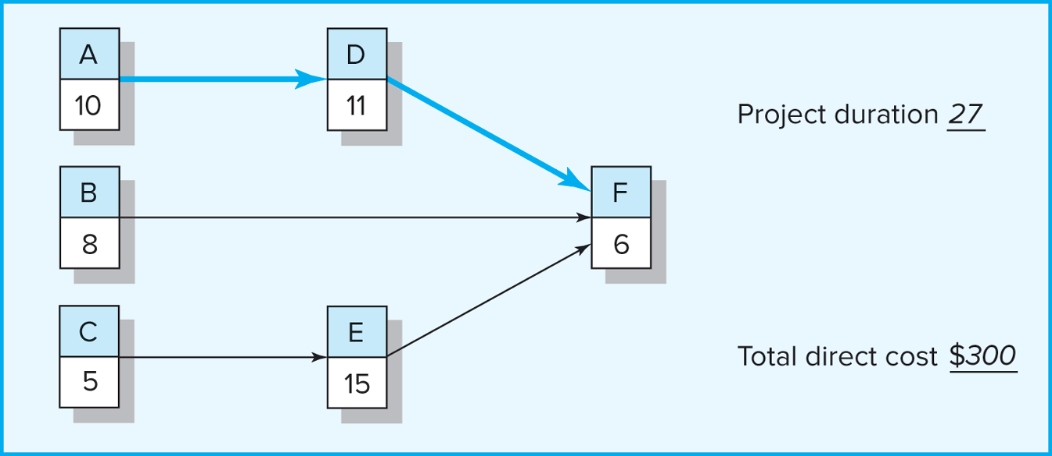

Solution: According to the project network, A-D-F is the critical path that duration is 27 days and total direct cost is 300$. So, the total cost equals to indirect costs plus total direct cost ($300\$+300\$=600\$$).

When the project duration is 26 days, firstly, the activity F has the minimum crash cost and it can reduce 1 day. The direct cost will become to 330$($300\$+30\$$), and then the indirect cost will become to 240$. So, the total cost will become to 570$($330\$+240\$$). The project network, which has been changed as shown below

A

10

D

11

B

8

F

5

C

5

E

15

When project duration is 25 days, firstly, the activity D has the minimum crash cost except activity F in this path and that can reduce 2 days. However, we just need to reduce 1 day that can achieve our aim. The direct cost will become to 380$($330\$+50\$$), and then the indirect cost will become to 180$. So, the total cost will become to 560$($380\$+180\$$). The project network, which has been changed as shown below

A

10

D

10

B

8

F

5

C

5

E

15

When the project duration is 24 days, we have two critical paths (A-D-F and C-E-F). Firstly, the activity C and the activity D has the minimum crash cost except activity F and the activity D. The direct cost will become to 470$($380\$+40\$+50\$$), and then the indirect cost will become to 120$. So, the total cost will become to 590$($470\$+120\$$). The project network, which has been changed as shown below

A

10

D

9

B

8

F

5

C

4

E

15

When the project duration is 23 days, we have two critical paths (A-D-F and C-E-F). Firstly, the activity A and the activity E are the rest activities. The direct cost will become to 650$($470\$+80\$+100\$$), and then the indirect cost will become to 60$. So, the total cost will become to 710$($650\$+60\$$). The project network, which has been changed as shown below

A

9

D

9

B

8

F

5

C

4

E

14

When the project duration is 22 days, we have two critical paths (A-D-F and C-E-F). Firstly, the activity A and the activity E are the rest activities. The direct cost will become to 830$($650\$+80\$+100\$$), and then the indirect cost will become to 50$. So, the total cost will become to 880$($830\$+50\$$). The project network, which has been changed as shown below

A

8

D

9

B

8

F

5

C

4

E

13

Compute the direct, indirect, and total costs for each duration.

|  |  |  |  |
| --- | --- | --- | --- |
| Time | Direct costs | Indirect costs | Total costs |
| 27 | 300$ | 300$ | 600$ |
| 26 | 330$ | 240$ | 570$ |
| 25 | 380$ | 180$ | 560$ |
| 24 | 470$ | 120$ | 590$ |
| 23 | 650$ | 60$ | 710$ |
| 22 | 830$ | 50$ | 880$ |

|  |  |  |  |
| --- | --- | --- | --- |
| Activity | Total time | Time | Total costs (customer offers me $10 for every day) |
| F | 26 | From 6 days to 5 days | 560 |
| D | 25 | From 11 days to 10 days | 540 |
| C, D | 24 | For C: From 5 days to 4 days  For D: From 10 days to 9 days | 560 |
| A, E | 23 | For A: From 10 days to 9 days  For E: From 15 days to 14 days | 670 |
| A, E | 22 | From 9 days to 8 days  For E: From 14 days to 13 days | 830 |

According to the above two tables, I think reduce the duration time to 25 days is the optimum cost-time schedule, because it has lowest total cost. If the customer offers me $10 for every day, reduce the duration time to 25 days is the best choice too, the reason is same as above.

**4 Project Networks and Scheduling (10 marks)**

You are managing a product upgrade project for VorTex. Given the project network that follows, complete forward and backward pass, compute activity slack, and identify the critical path. Use this information to create a Gantt chart for the project in MS Project. Be sure to show slack for noncritical activities.

1. Fill out the gaps in the following picture. (5 marks)

2. Create the corresponding Gantt chart (5 marks)

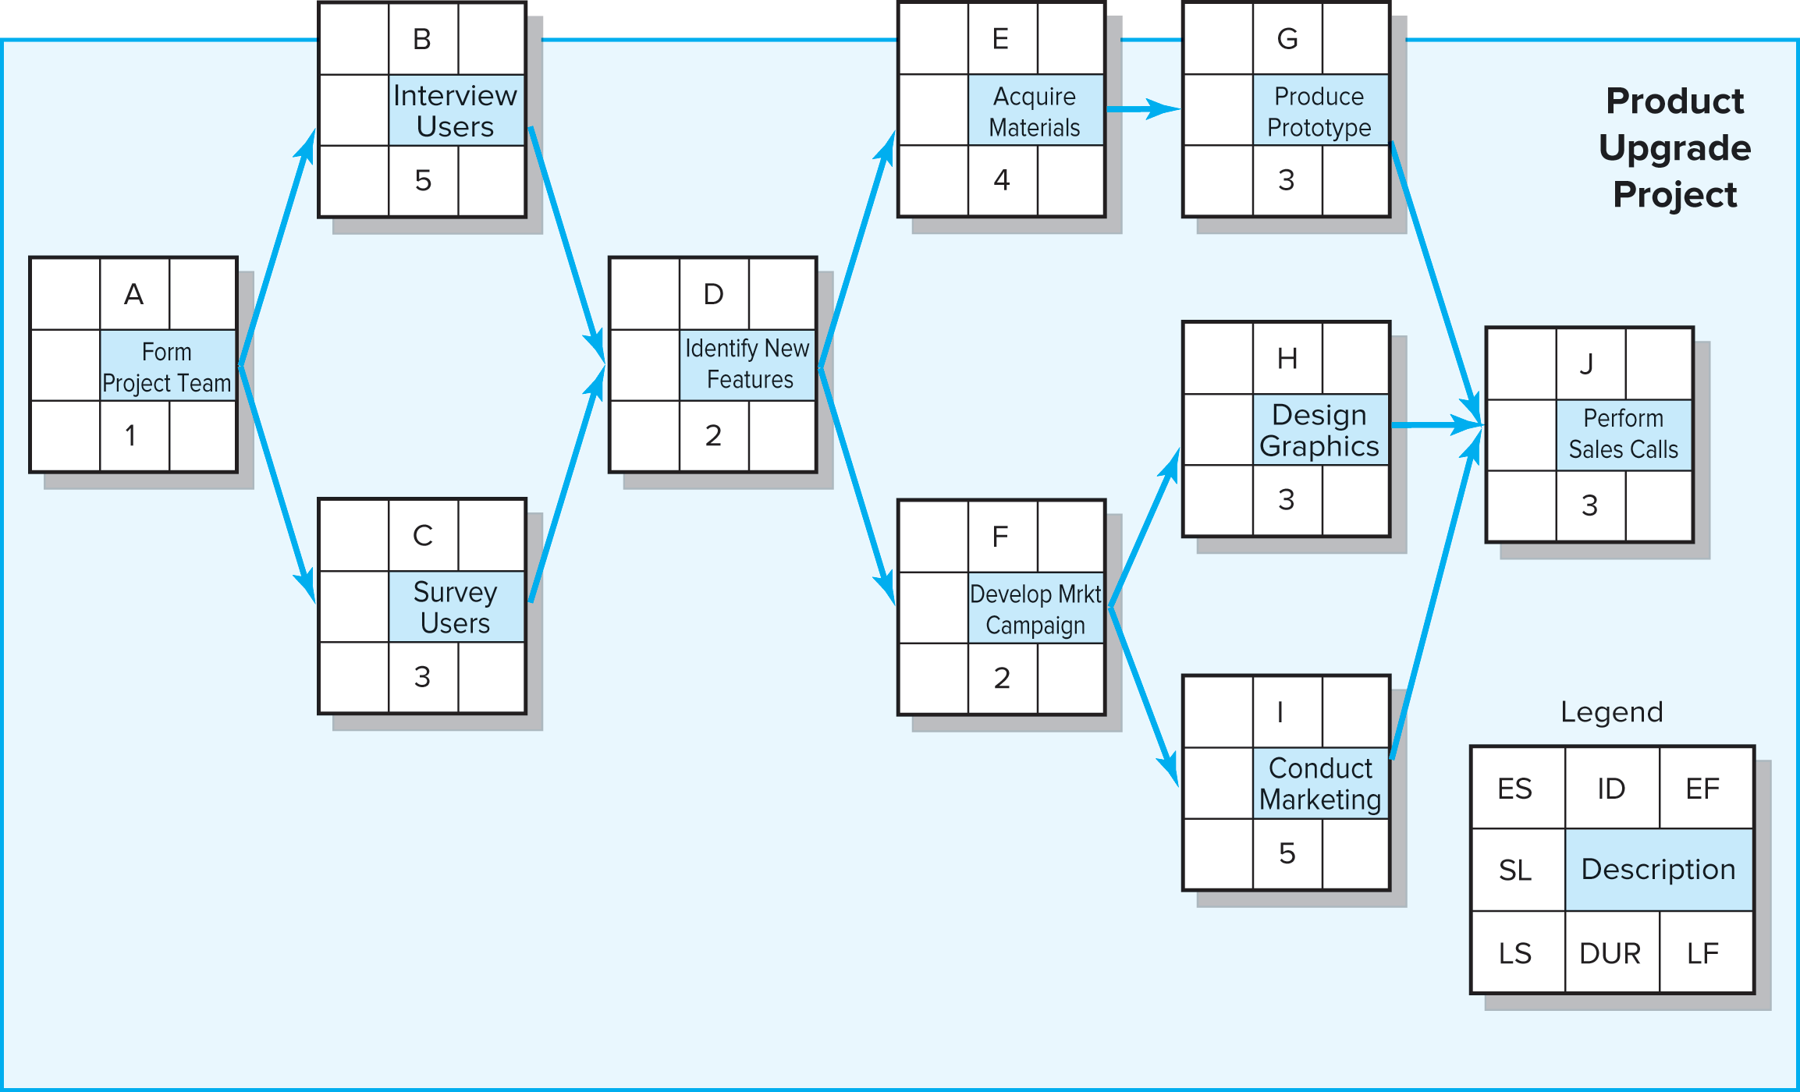

Solution: 1. The answer as shown below

|  |  |  |
| --- | --- | --- |
| 12 | G | 15 |
| 0 | Produce Prototype | |
| 12 | 3 | 15 |

|  |  |  |
| --- | --- | --- |
| 8 | E | 12 |
| 0 | Acquire Materials | |
| 8 | 4 | 12 |

|  |  |  |
| --- | --- | --- |
| 1 | B | 6 |
| 0 | Interview  Users | |
| 1 | 5 | 6 |

|  |  |  |
| --- | --- | --- |
| 0 | A | 1 |
| 0 | Form  Project Team | |
| 0 | 1 | 1 |

|  |  |  |
| --- | --- | --- |
| 6 | D | 8 |
| 0 | Identify New Features | |
| 6 | 2 | 8 |

|  |  |  |
| --- | --- | --- |
| 15 | J | 18 |
| 0 | Perform Sales Calls | |
| 15 | 3 | 18 |

|  |  |  |
| --- | --- | --- |
| 10 | H | 13 |
| 2 | Design Graphics | |
| 12 | 3 | 15 |

|  |  |  |
| --- | --- | --- |
| 8 | F | 10 |
| 0 | Form  Project Team | |
| 8 | 2 | 10 |

|  |  |  |
| --- | --- | --- |
| 1 | C | 4 |
| 2 | Survey  Users | |
| 3 | 3 | 6 |

|  |  |  |
| --- | --- | --- |
| 10 | I | 15 |
| 0 | Conduct Marketing | |
| 10 | 5 | 15 |

2. The corresponding Gantt chart as shown below

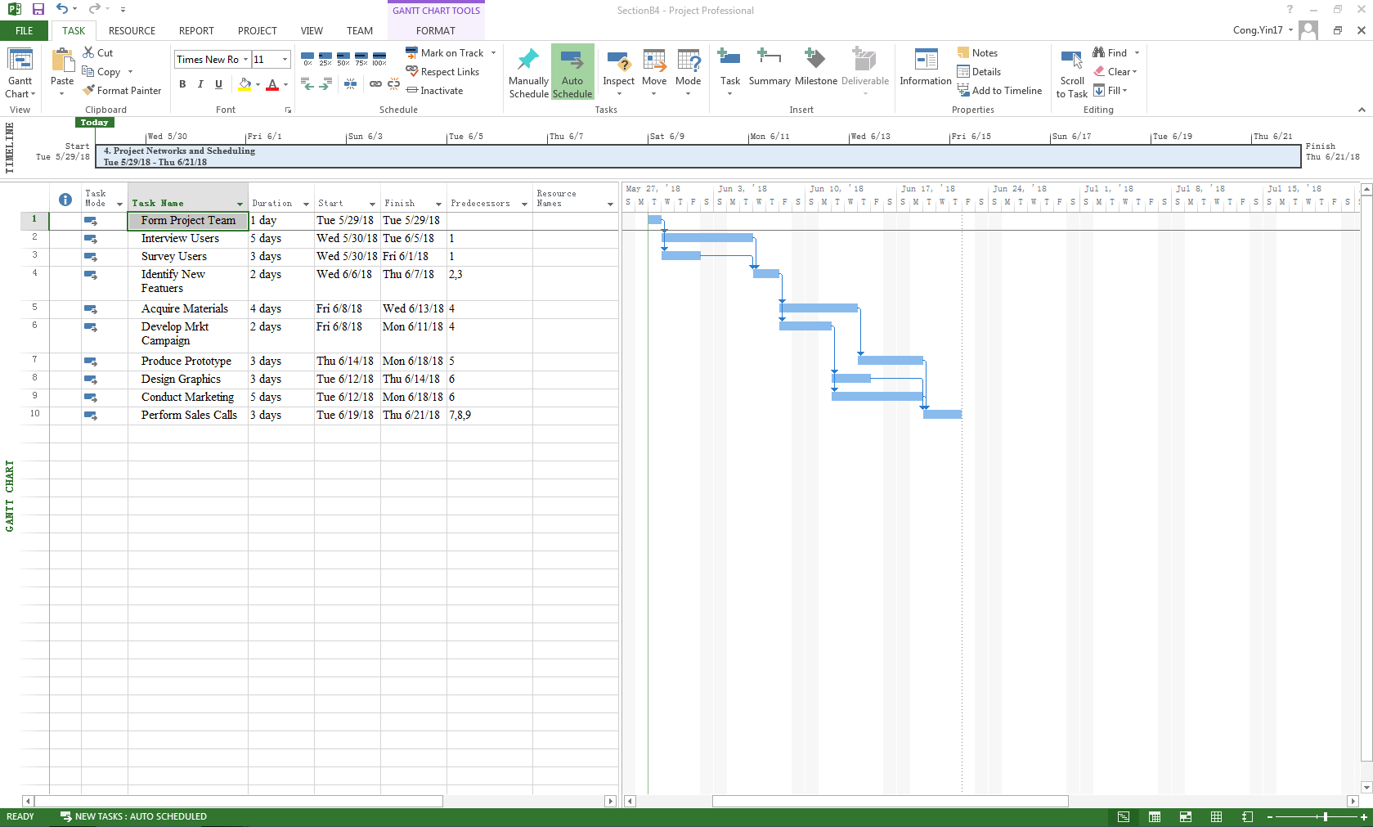

**5 Developing a new mobile device (10 marks)**

The planning department of a large manufacturer has determined the following steps for the development of a mobile device. Given this information develop the Gantt chart in MS Project assuming a five day work week and starting on January 4th. Can the project be completed within 45 weeks?

|  |  |  |  |
| --- | --- | --- | --- |
| **Activity** | **Description** | **Predecessor** | **Time (weeks)** |
|  |  |  |  |
| 1 | Staff | None | 2 |
| 2 | Develop market program | 1 | 3 |
| 3 | Select channels of distribution | 1 | 8 |
| 4 | Patent | 1 | 12 |
| 5 | Pilot production | 1 | 4 |
| 6 | Test market | 5 | 4 |
| 7 | Ad promotion | 2 | 4 |
| 8 | Set up for production | 4, 6 | 16 |

1. Create the Gantt chart in MS Project and answer the question whether the Project can be completed in time. (7 marks)
2. What suggestions, in general terms, exist when you need to shorten project duration? (3 marks)

A. 1. The corresponding Gantt chart as shown below

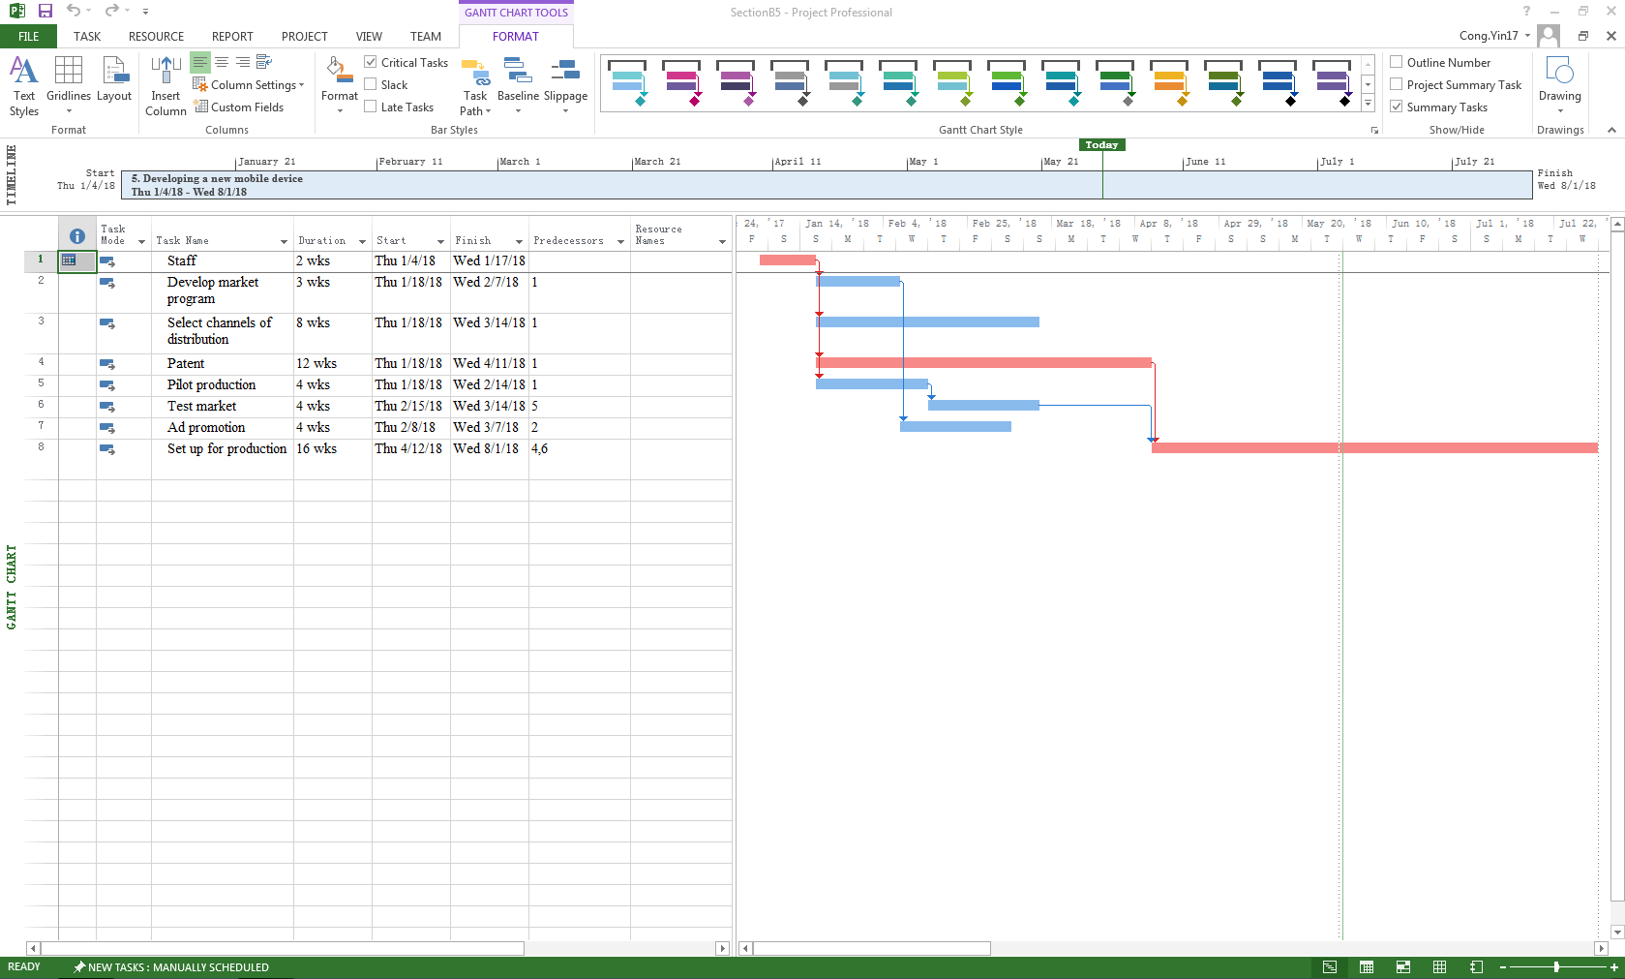

According to the Gantt chart, the project will be completed on August 1st. Sum the time, which can be used of activity 1, activity 4 and activity 8, the totally time which can be used is 30 weeks. So, this project can be completed within 45 weeks.

2. when I need to shorten project duration, firstly, I need to improve the productivity of existing project. Secondly, change the working method employed for the activity, usually by altering the technology and types of resources employed. Thirdly, compromise quality and/or reduce project scope. And then, for fast-track the project, there are three rules. Shorten the longest critical activities, partially overlap activities and employ Start to Start lag relationships. Finally, use overtime and add resources to the project team can also help me to solve this problem.

## **Section C Complete one of the case studies (25 marks).**

CASE A: Shoreline Stadium

The G&E Company is preparing a bid to build the new 47,000-seat Shoreline baseball stadium. The construction must start on July 3, 2017, and be completed in time for the start of the 2020 season. A penalty clause of $250,000 per day of delay beyond April 3 is written into the contract.

Percival Young, the president of the company, expressed optimism at obtaining the contract and revealed that the company could net as much as $3 million on the project. He also said if they were successful, the prospects of future projects are bright since there is a projected renaissance in building classic ball parks with modern luxury boxes. Given the information from the table on the next page answer the following questions:

1. Will the project be able to be completed by the April 3 deadline? How long will it take? Include the MS Project file (12 marks)
2. What is the critical path for the project? (3 marks)
3. Based on the schedule would you recommend that G&E pursue this contact? Why? (10 marks)

|  |  |  |  |
| --- | --- | --- | --- |
| ID | Activity | Duration | Predecessor(s) |
| 1 | Baseball Stadium |  |  |
| 2 | Clear stadium site | 70 days | — |
| 3 | Demolish building | 30 days | 2 |
| 4 | Set up construction site | 70 days | 3 |
| 5 | Drive support piling | 120 days | 4 |
| 6 | Pour lower concrete bowl | 120 days | 5 |
| 7 | Pour main concourse | 120 days | 6 |
| 8 | Install playing field | 90 days | 6 |
| 9 | Construct upper steel bowl | 120 days | 6 |
| 10 | Install seats | 140 days | 9 |
| 11 | Build luxury boxes | 90 days | 9 |
| 12 | Install jumbotron | 30 days | 9 |
| 13 | Stadium infrastructure | 120 days | 9 |
| 14 | Construct steel canopy | 75 days | 10 |
| 15 | Light installation | 30 days | 10 |
| 16 | Build roof supports | 90 days | 4 |
| 17 | Construct roof | 180 days | 16 |
| 18 | Install roof tracks | 90 days | 14 |
| 19 | Install roof | 90 days | 17, 18 |
| 20 | Inspection | 20 days | 8, 11, 13, 15, 19 |

Solution: 1. The corresponding Gantt chart as shown below

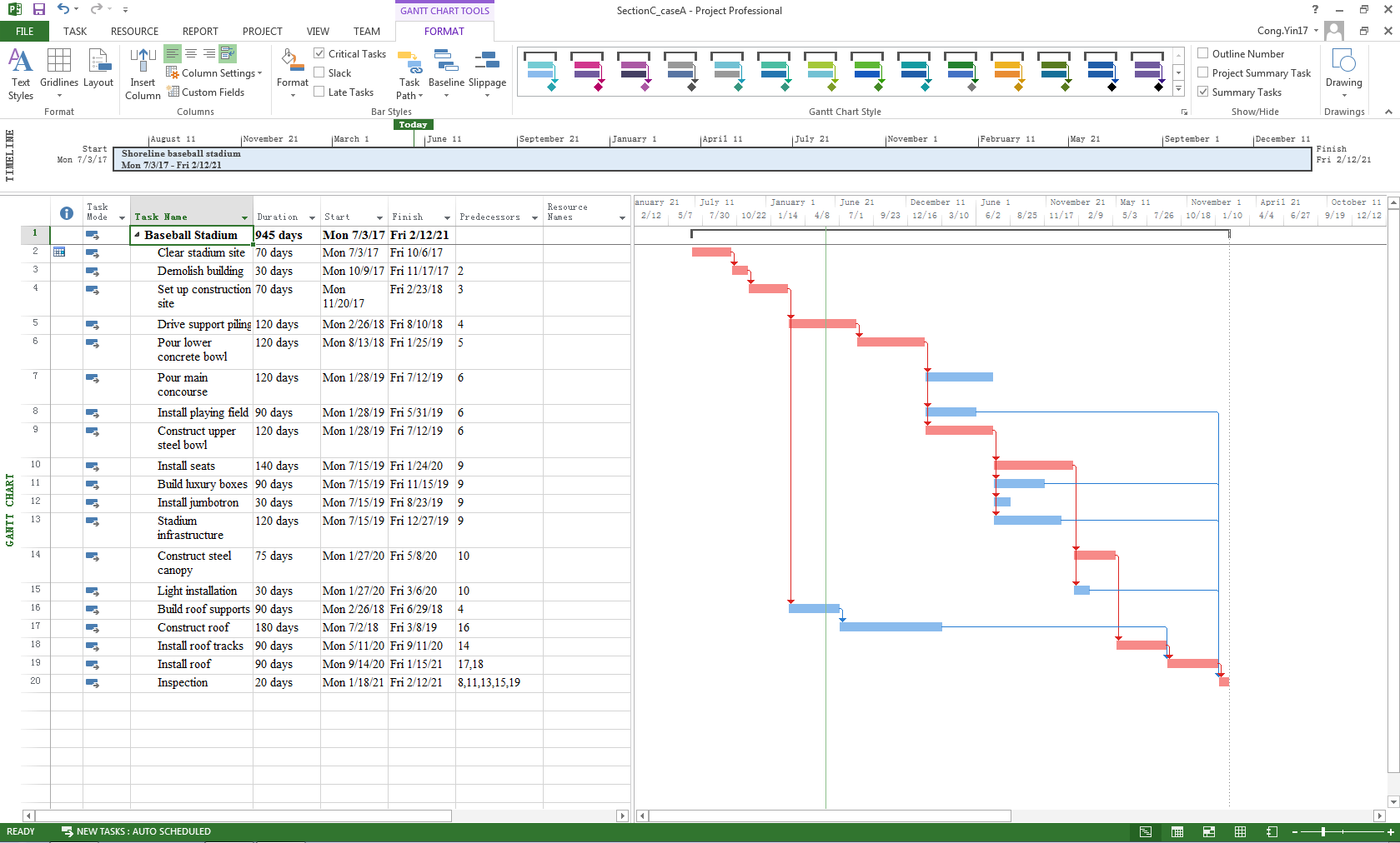

According to the Gantt chart, this project cannot be completed by the April 3, 2020. Although according to the critical path, this project will take 945 days (working days). However, as a matter of fact, this project will be finished after deadline for almost year (include day off).

2. The critical path as shown in the above Gantt chart and display in red.

3. My suggestion is rescheduled the project or try to get the work done faster that means crashing. Because if based on the schedule, this project will be finished after deadline for almost year. And then, a penalty clause of $250,000 per day of delay beyond April 3. It is means that not only cannot earn any money, but also it will become a losing business. From start time to deadline, it has 1032 days. In other words, the time is enough to complete this project. Firstly, I think this company should give up this project or change several activities until this project can complete on time. Secondly, If the crashing cost can be acceptable, crashing is the best choice. That will follow the rule of crashing. And it will minimum reduce 87days.

**CASE B: Risk and Response**

Read the three cases and answer the two questions for each case individually.

**Questions**:

1. What are the associated risks for each Project? Name at least five (5) with a brief description. (10 marks)
2. Complete a risk response matrix for **three** (3) of the risks for each case. (15 marks)

### Case B1: Silver Fiddle Construction

You are the president of Silver Fiddle Construction (SFC), which specializes in building high-quality, customized homes in the Grand Junction, Colorado, area. You have just been hired by the Czopeks to build their dream home. You operate as a general contractor and employ only a part-time bookkeeper. You subcontract work to local trade professionals. Housing construction in Grand Junction is booming. You are tentatively scheduled to complete 11 houses this year. You have promised the Czopeks that the final costs will range from $450,000 to $500,000 and that it will take five months to complete the house once groundbreaking has begun. The Czopeks are willing to have the project delayed in order to save costs.

You have just finished a preliminary scope statement for the project (see next page). You are now brainstorming potential risks associated with the project.

PROJECT SCOPE STATEMENT

PROJECT OBJECTIVE

To construct a high-quality, custom home within five months at a cost not to exceed $500,000.

DELIVERABLES

A 2,500-square-foot, 2½-bath, 3-bedroom, finished home.

A finished garage, insulated and sheetrocked. Kitchen appliances to include range, oven, microwave, and dishwasher. High-efficiency gas furnace with programmable thermostat.

MILESTONES

* Permits approved July 5.
* Foundation poured July 12.
* “Dry in”—framing, sheathing, plumbing, electrical, and mechanical inspections—passed September 25.
* Final inspection November 7.

TECHNICAL REQUIREMENTS

* Home must meet local building codes.
* All windows and doors must pass NFRC class 40 energy ratings.
* Exterior wall insulation must meet an “R” factor of 21.
* Ceiling insulation must meet an “R” factor of 38.
* Floor insulation must meet an “R” factor of 25.
* Garage will accommodate two cars and one 28-foot-long Winnebago.
* Structure must pass seismic stability codes.

LIMITS AND EXCLUSIONS

* The home will be built to the specifications and design of the original blueprints provided by the customer.
* Owner is responsible for landscaping.
* Refrigerator is not included among kitchen appliances.
* Air conditioning is not included, but house is prewired for it.
* SFC reserves the right to contract out services.

CUSTOMER REVIEW

* “Bolo” and Izabella Czopek.

### Case B2 Trans LAN Project

Trans Systems is a small information systems consulting firm located in Meridian, Louisiana. Trans has just been hired to design and install a local area network (LAN) for the city of Meridian’s social welfare agency. You are the manager for the project, which includes one Trans professional and two interns from a local university. You have just finished a preliminary scope statement for the project (see next page). You are now brainstorming potential risks associated with the project.

PROJECT SCOPE STATEMENT

PROJECT OBJECTIVE

To design and install a new local area network (LAN) within one month with a budget not to exceed $90,000 for the Meridian Social Service Agency with minimum disruption to ongoing operations.

DELIVERABLES

* Twenty workstations and twenty laptop computers.
* Server with dual-core processors.
* Two color laser printers.
* Windows R2 server and workstation operating system (Windows 10).
* Migration of existing databases and programs to new system.
* Four hours of introduction training for client’s personnel.
* Sixteen hours of training for client network administrator.
* Fully operational LAN system.

MILESTONES

* Hardware January 22.
* Setting users’ priority and authorization January 26.
* In-house whole network test completed February 1.
* Client site test completed February 2.
* Training completed February 16.

TECHNICAL REQUIREMENTS

* Workstations with 17-inch flat panel monitors, dual-core processors, 4 GB RAM, 8X DVD+RW, wireless card, Ethernet card, 500 GB hard drive.
* Laptops with 12-inch display monitor, dual-core processors, 2GB RAM, 8X DVD+RW, wireless card, Ethernet card, 500 GB hard drive and weigh less than 4½ lbs.
* Wireless network interface cards and Ethernet connections.
* System must support Windows 11 platforms.
* System must provide secure external access for field workers.

LIMITS AND EXCLUSIONS

* On-site work to be done after 8:00 p.m. and before 7:00 a.m. Monday through Saturday.
* System maintenance and repair only up to one month after final inspection.
* Warranties transferred to client.
* Only responsible for installing software designated by the client two weeks before the start of the project.
* Client will be billed for additional training beyond that prescribed in the contract.

CUSTOMER REVIEW

Director of the city of Meridian’s Social Service Agency.

### CASE B3 XSU Spring Concert

You are a member of the X State University (XSU) student body entertainment committee. Your committee has agreed to sponsor a spring concert. The motive behind this concert is to offer a safe alternative to Hasta Weekend. Hasta Weekend is a spring event in which students from XSU rent houseboats and engage in heavy partying. Traditionally this occurs during the last weekend in May. Unfortunately, the partying has a long history of getting out of hand, sometimes leading to fatal accidents. After one such tragedy last spring, your committee wants to offer an alternative experience for those who are eager to celebrate the change in weather and the pending end of the school year.

You have just finished a preliminary scope statement for the project (see next page). You are now brainstorming potential risks associated with the project.

PROJECT SCOPE STATEMENT

PROJECT OBJECTIVE

To organize and deliver an eight-hour concert at Wahoo Stadium at a cost not to exceed $50,000 on the last Saturday in May.

DELIVERABLES

* Local advertising.
* Concert security.
* Separate Beer Garden.
* Eight hours of music and entertainment.
* Food venues.
* Souvenir concert T-shirts.
* Secure all licenses and approvals.
* Secure sponsors.

MILESTONES

* Secure all permissions and approvals by January 15.
* Sign big-name artist by February 15.
* Complete artist roster by April 1.
* Secure vendor contracts by April 15.
* Setup completed on May 27.
* Concert on May 28.
* Cleanup completed by May 31.

TECHNICAL REQUIREMENTS

* Professional sound stage and system.
* At least one big-name artist.
* At least seven performing acts.
* Restroom facilities for 10,000 people.
* Parking available for 1,000 cars.
* Compliance with XSU and city requirements/ordinances.

LIMITS AND EXCLUSIONS

* Performers responsible for travel arrangements to and from XSU.
* Vendors contribute a set percentage of sales.
* Concert must be over by 11:30 p.m.

CUSTOMER REVIEW

* The president of XSU student body.

**-----END OF PAPER-----**